Interior Design Project Management System
Overview:
The system is designed to assist interior designers in managing their projects and communicating with their clients. It provides solutions for project management, including creating and managing projects, handling employees and suppliers, planning costs, and color matching. Additionally, there is a design questionnaire feature to gain a deeper understanding of client preferences.
System Components:
- Login and Registration Page:
  - Purpose: Allows users to register and create a new account or log into an existing account.
  - Usage: Users can choose to register as either a designer or a client during registration.
- Project Management Page (Designers):
  - Purpose: Displays all projects for a designer and allows them to add new projects.
  - Usage: The designer can enter project details, link the project to a specific client, and manage existing projects.
- Employee and Supplier Management:
  - Employee Management: Allows the designer to add information about employees, including their roles, rates, and names.
  - Supplier Management: Allows adding details about suppliers and products, including store names, contacts, and prices.
- Project Planning:
  - Purpose: Provides tools for the designer to plan projects, add notes, and calculate overall costs.
  - Usage: Includes a calculator to compute total costs based on employees and suppliers.
- Color Matching:
  - Purpose: Allows the designer to visualize color options and how they blend together in different rooms.
  - Usage: Users can select colors and see how they look when placed next to each other.
- Design Questionnaire:
  - Purpose: Helps the designer understand the client's style and preferences more deeply by gathering detailed responses.
  - Usage: The designer can create a questionnaire with options for the client to choose from. Each option can include an image to illustrate what is meant, aiding the client in making informed choices.
2. Internet Technologies
3.1 Front-End:
- HTML, CSS, JavaScript: For building the user interface and handling data interactions with the server.
3.2 Back-End:
- Node.js with Express: For building the server and APIs.
- Mongoose: For managing interactions with MongoDB.
3.3 Database:
- MongoDB: For managing user and project data.
3.4 Platform:
- Web: The system is designed for a web platform, allowing access via a browser.
3.5 Additional Tools:
- Postman: Used for testing APIs to ensure that endpoints function correctly and return the expected responses.

4. Screen prints:
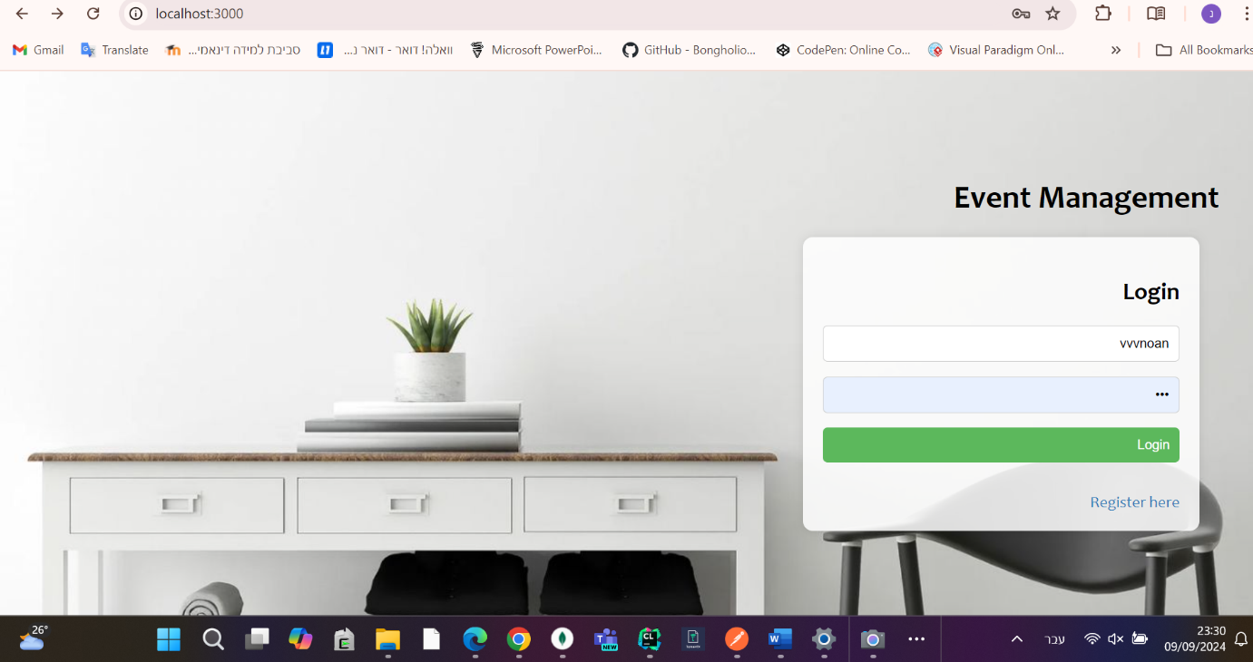
Login window

Registration window

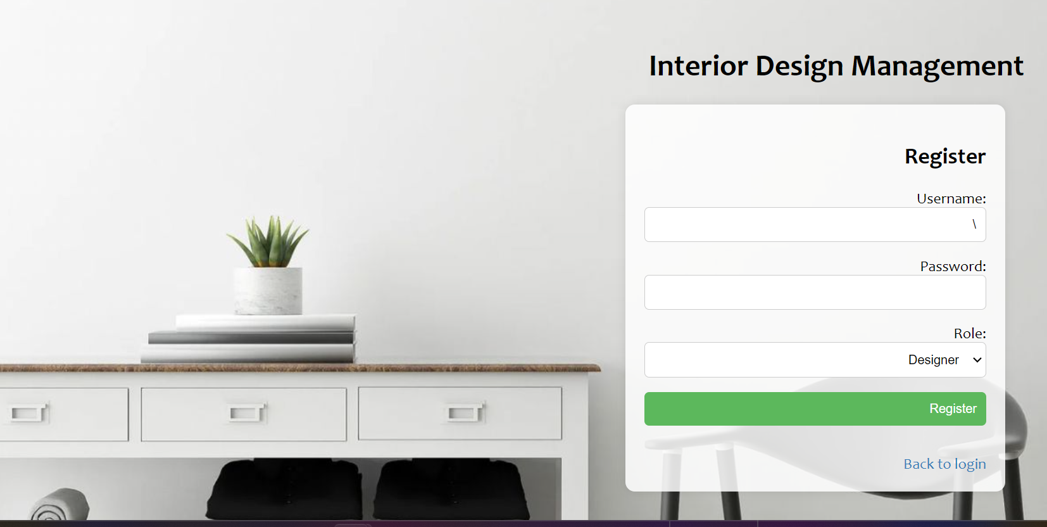

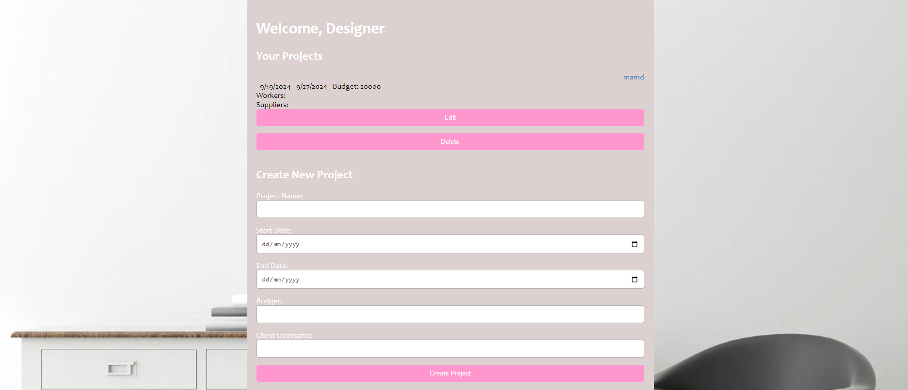
Designer projects presentation page

Designer projects presentation page

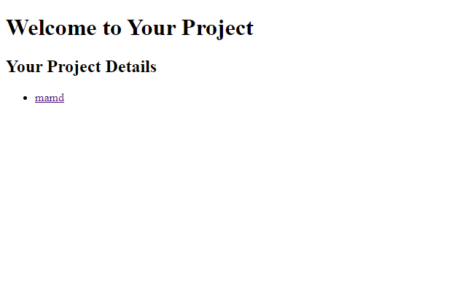

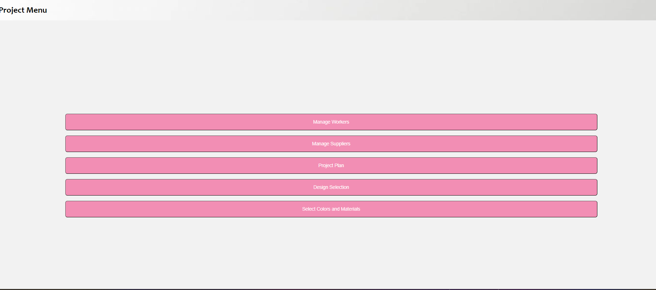
The menu you enter when you click on the project
Manage workers window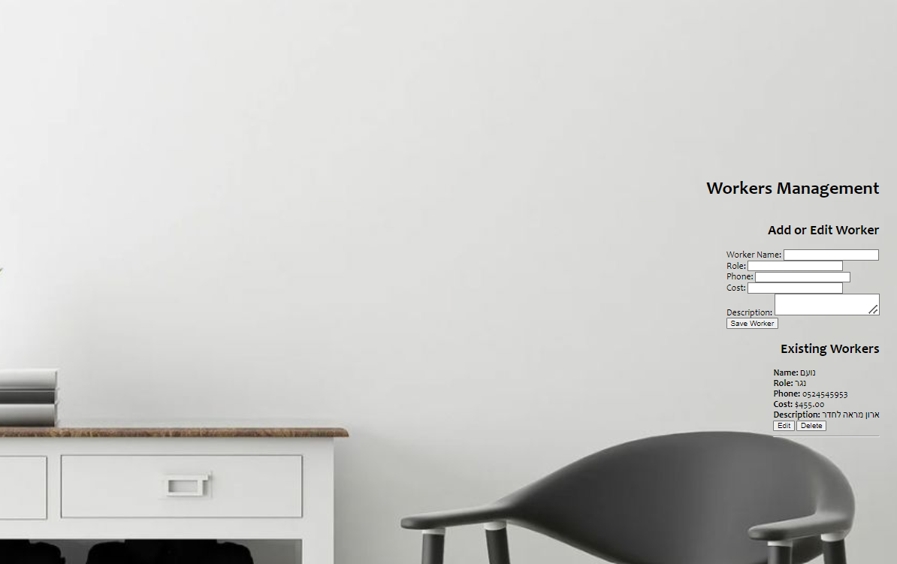

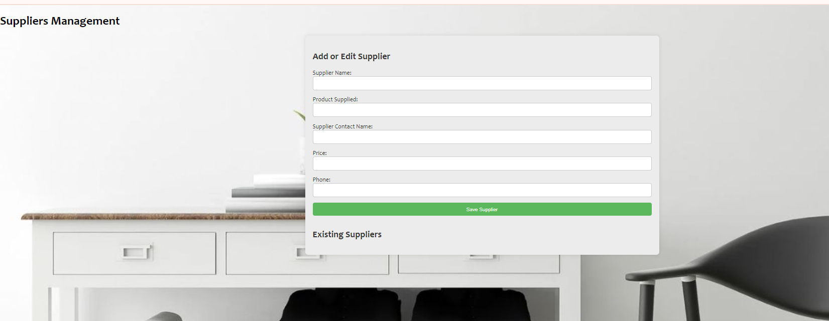
Manage Suppliers window

Project plan window
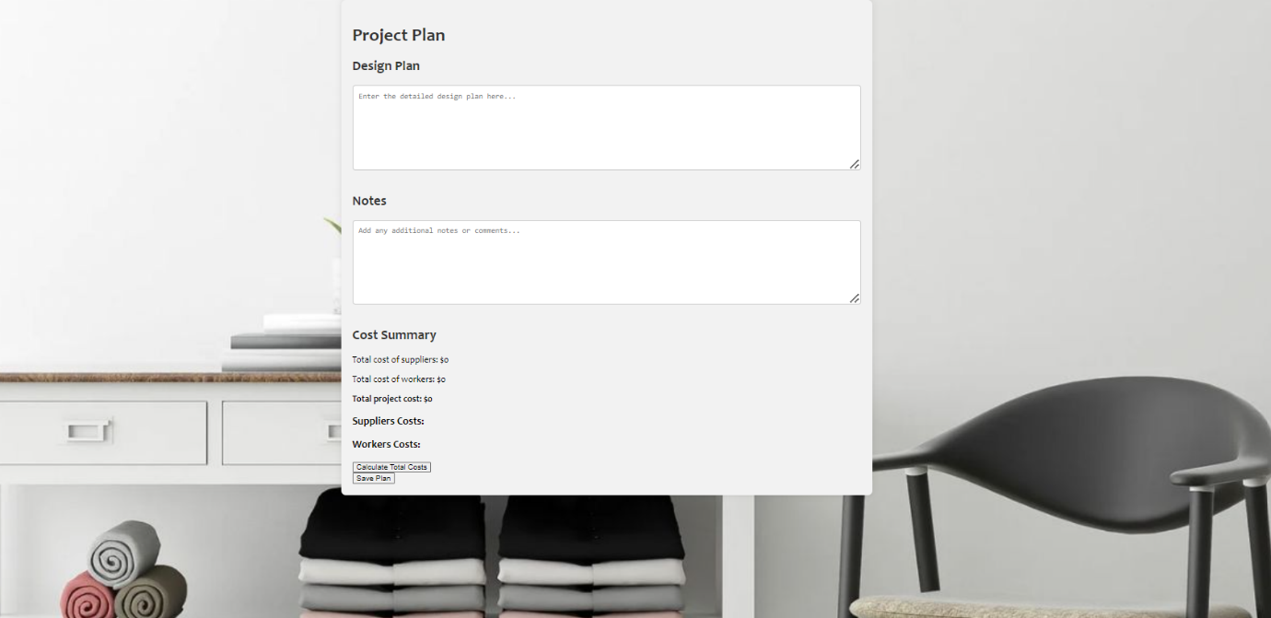

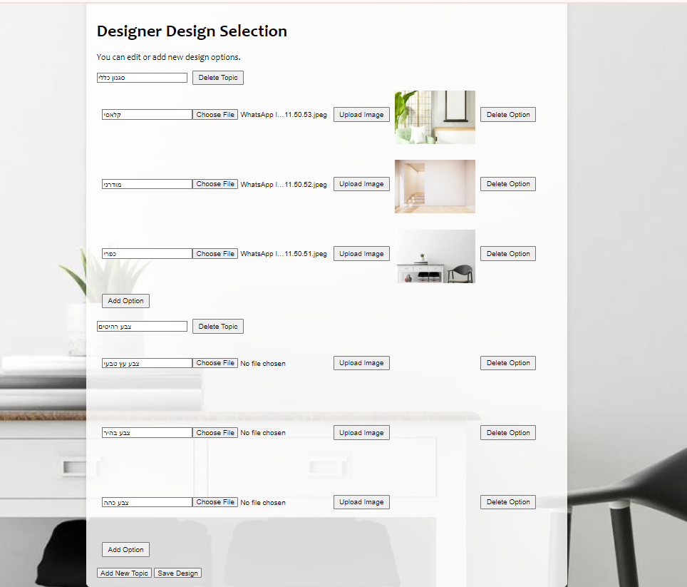
Design Selection

Select Rooms Colors And Materials window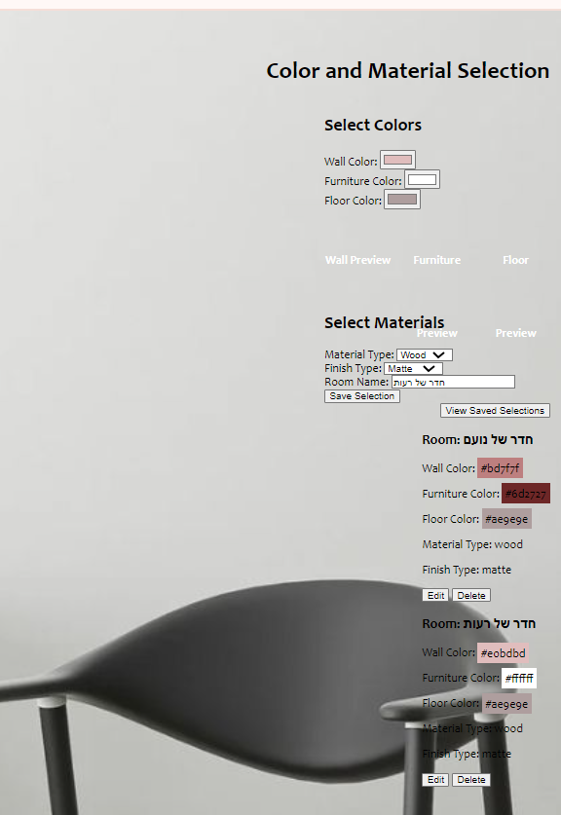

5. Diagrams:
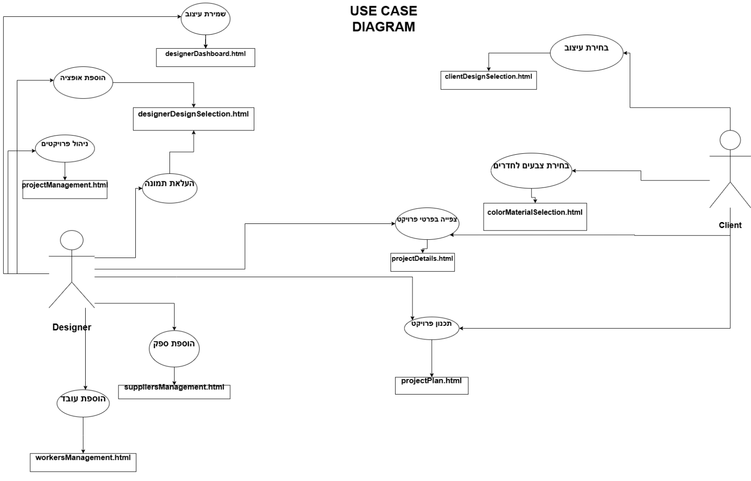
USECASE:

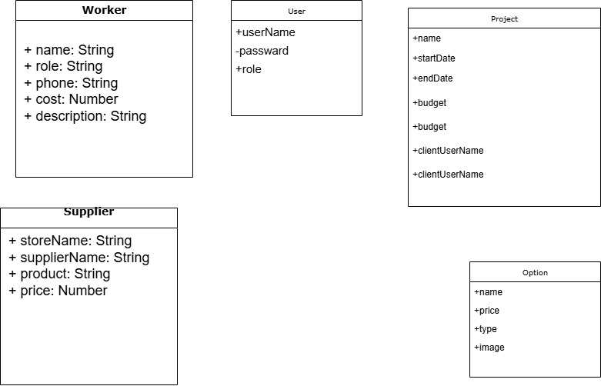

6.
Multer: לניהול קבצים מועלים.
Bcryptjs: לאבטחת סיסמאות.
Jsonwebtoken: לניהול אסימונים.

